- Applications of methods of drawing lines in space.

Values:
- Awareness of projecting line in space Accuracy in determining true lengths of inclined lines
TEACHING AIDS
……………………………………………………………………………………………………………………………………………

PART | LESSON CONTENT | METHODOLO GY | LEARNER ACTIVITY
introduction | - Recap on the previous lesson | Questions and answers | Provide answers
Developme nt | LINES IN SPACE  Draw given drawing and determine the True length of line AB inclined to HP and VP.  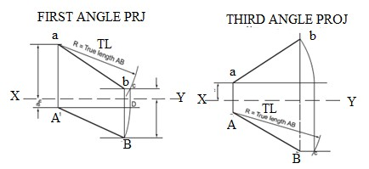 | Questions And Answers  Demonstration  V/E | Taking note of important points  Provide answers
Application | CLASS EXERCISE  1. Draw given drawing and determine the True length of line AB inclined to HP and VP using first and third angle projection  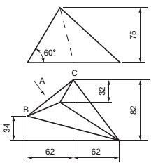 | Questions And Answers | Provide answers
Conclusion | - Recap on the main steps and points | V/E

Values:
- Awareness of projecting line in space Accuracy in determining true lengths of inclined lines
TEACHING AIDS
……………………………………………………………………………………………………………………………………………

PART | LESSON CONTENT | METHODOLO GY | LEARNER ACTIVITY
introduction | - Recap on the previous lesson | Questions and answers | Provide answers
Developme nt | LINES IN SPACE  Determine the True shape and angle of inclination of a triangular lamina given the plan and elevation  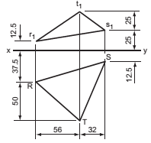 | Questions And Answers  Demonstration  V/E | Taking note of important points  Provide answers
Application | CLASS EXERCISE  determine the True shape and angle of inclination of a triangular lamina given the plan and elevation  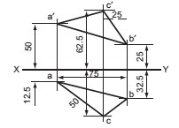 | Questions And Answers | Provide answers
Conclusion | - Recap on the main steps and points | V/E

Values:
- Awareness of projecting line in space Accuracy in determining true lengths of inclined lines
TEACHING AIDS
……………………………………………………………………………………………………………………………………………

PART | LESSON CONTENT | METHODOLO GY | LEARNER ACTIVITY
introduction | - Recap on the previous lesson | Questions and answers | Provide answers
Developme nt | LINES IN SPACE  Draw given drawing and determine the True length of line AB inclined to HP and VP. | Questions And Answers  Demonstration  V/E | Taking note of important points  Provide answers
Application | CLASS EXERCISE  2. Draw given drawing and determine the True length of line AB inclined to HP and VP using first and third angle projection | Questions And Answers | Provide answers
Conclusion | - Recap on the main steps and points | V/E

Values:
- Awareness of projecting line in space Accuracy in determining true lengths of inclined lines
TEACHING AIDS
……………………………………………………………………………………………………………………………………………

PART | LESSON CONTENT | METHODOLO GY | LEARNER ACTIVITY
introduction | - Recap on the previous lesson | Questions and answers | Provide answers
Developme nt | LINES IN SPACE  Draw given drawing and determine the True length of line AB inclined to HP and VP. | Questions And Answers  Demonstration  V/E | Taking note of important points  Provide answers
Application | CLASS EXERCISE  3. Draw given drawing and determine the True length of line AB inclined to HP and VP using first and third angle projection | Questions And Answers | Provide answers
Conclusion | - Recap on the main steps and points | V/E

Values: Awareness of projecting line in space Accuracy in determining true lengths of inclined lines
TEACHING AIDS
……………………………………………………………………………………………………………………………………………

PART | LESSON CONTENT | METHODOLO GY | LEARNER ACTIVITY
introduction | - Recap on the previous lesson | Questions and answers | Provide answers
Developme nt | LINES IN SPACE  Draw given drawing and determine the True length of line AB inclined to HP and VP. | Questions And Answers  Demonstration  V/E | Taking note of important points  Provide answers
Application | CLASS EXERCISE  4. Draw given drawing and determine the True length of line AB inclined to HP and VP using first and third angle projection | Questions And Answers | Provide answers
Conclusion | - Recap on the main steps and points | V/E

